Light
Sunlight
Sun light is a portion of the electromagnetic radiation given off by the sun, infrared, visible and ultraviolet light. On Earth sunlight is scattered and filtered through Earth’s atmosphere, sun is above the horizon. 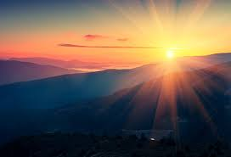

Five Sources of Visible Light

Sun,
Moon,
Led (Light Emitting diode,)
Tube Light and
Electric Bulb.

Man Made Light
Artificial light is created by humans. Flashlights, table lamps, neon signs, and televisions are some sources of artificial light. Most of the lights that are man-made need an energy source, such as electricity or batteries, to produce light.
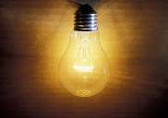

Fire

Fire is also a source of light. This could be in the form of candles, open fire, paraffin lamps. Fire is both Man Made and Natural. It can be Natural because you can leave glass out and it will get hot and eventually set fire or the ground can get hot and set fire, particularly Moorland’s.

