**Forest School**

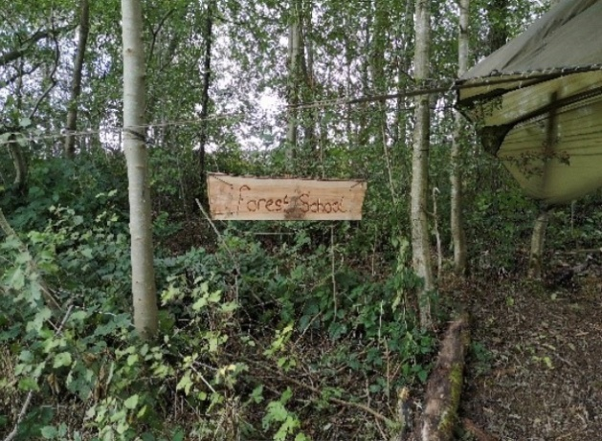

**at**

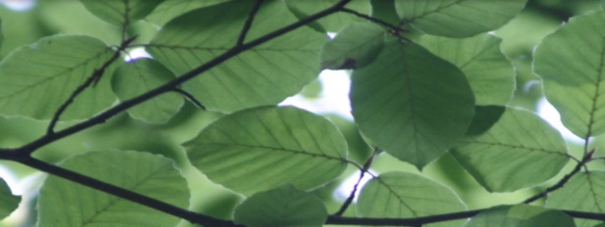**Waterhouses CE**

**Primary Academy & Nursery**

What are the benefits?

Forest Schools supports the holistic development of every child:

» Health and fitness – being active in an outdoor, natural environment.

» Increased emotional wellbeing.

» Communicating with peers and adults to solve problems and share experiences.

» Skills development – developing fine and gross motor skills and coordination.

» Gaining knowledge and understanding – multi–sensory, real-life learning.

» Curriculum Links – Forest Schools supports many areas of the Early Years Foundation Stage framework, National Curriculum and the Every Child Matters agenda.

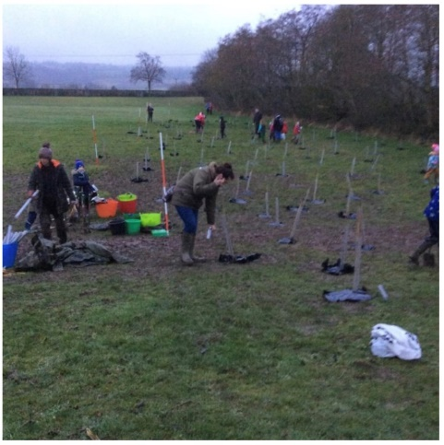

Tree Planting

In January 2020 over 100 adults and children were welcomed to plant a selection of trees from the Woodland Trust and TCV (The Conservation Volunteers). The event was led by Katie, Forest School practitioner from Tanglewood.

The aim was to help increase the number of species in the wooded area and encourage a greater diversity of wildlife in the coming years for our future generations to experience and explore. This has been achieved with the help of the school’s PTFA.

333333

What do we do?

Children will be involved in lots of exciting activities:

» singing the forest school song

» campfire cooking

» fire building

» shelter building

» using woodland hand tools

» wildlife and sensory activities

» nature crafts

» team building and trust games

» and obviously drinking hot chocolate

What is it?

Forest School provides new learning experiences for the children, and the teachers, at Waterhouses school in a woodland / natural environment with trees.

Where is it?

The area used for forest school is within the copse at the end of the playing field on the school site. A log circle has been set up as a base camp where there is a fire pit.

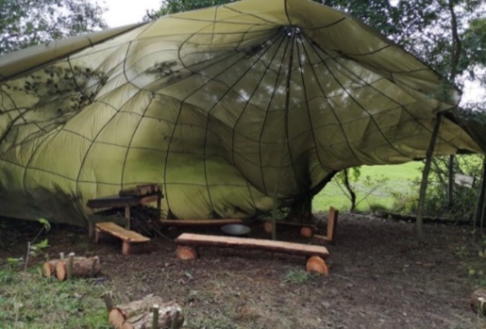

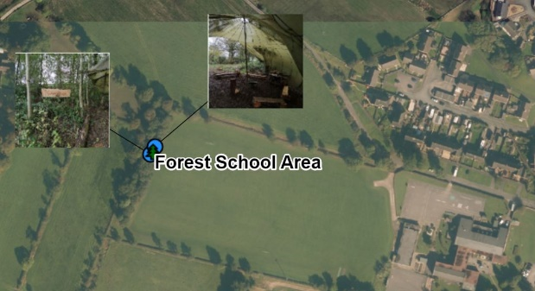

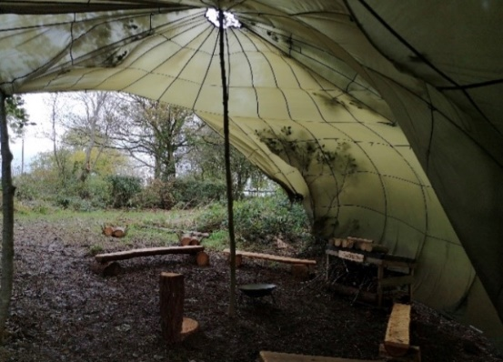

What if it Rains?

Wet weather does not stop our learning! A canopy is in place especially for rainy days because pupils go out in all weather (except high winds) wearing waterproofs and boots.

