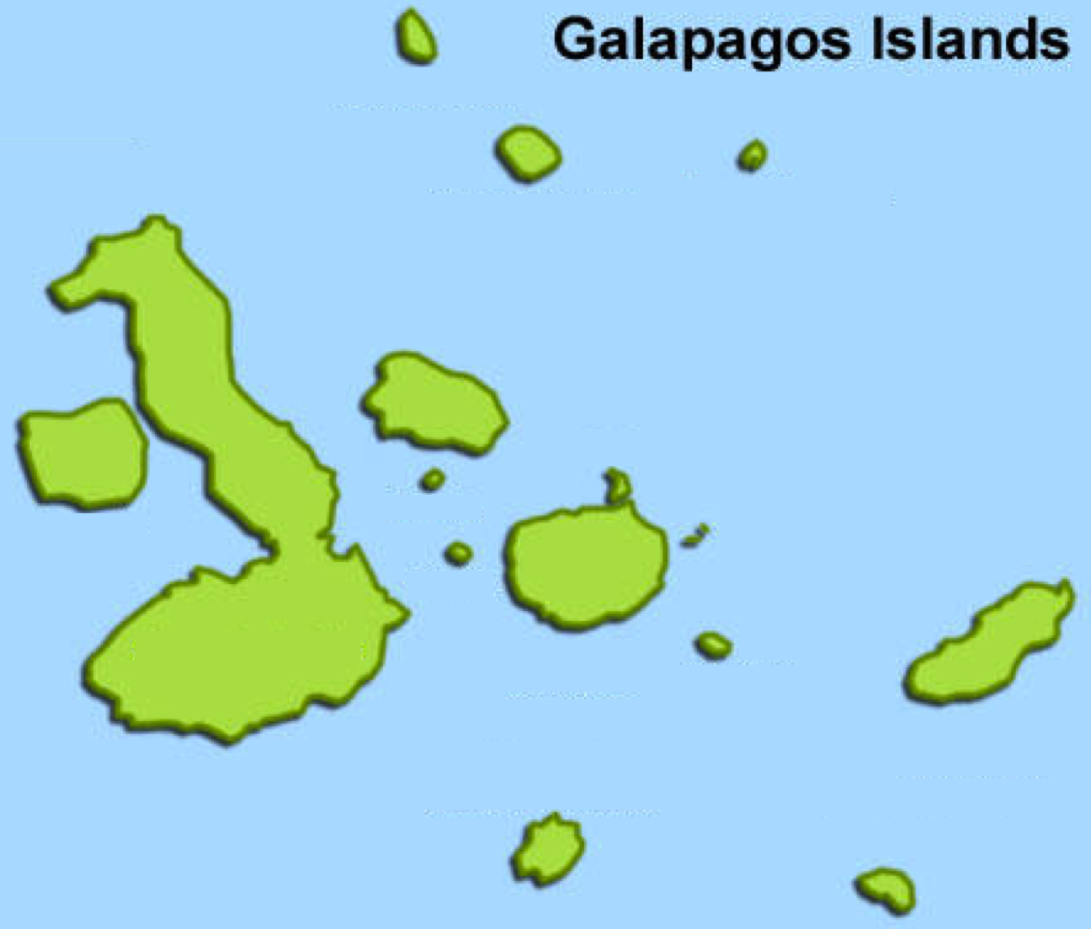

**Espanola**

Small flying insects, cacti and small seeds

**Santa Fe**

Small flying insects and insects on leaves, small seeds and cacti

**Fernandina**

Small and large seeds, small insects on leaves, grubs found inside twigs, fruit and flying insects

**Santa Cruz**

Small and large seeds, small insects on leaves, grubs found inside twigs, flying insects, fruit and cacti

**Isabela**

Small and large seeds, cacti, small insects on leaves, grubs found inside twigs, flying insects and fruit

**Genovesa**

Large seeds, cacti, small flying insects

**Plaza**

Small seeds and cacti

**Floreana**

Small seeds, cacti, small insects on leaves, grubs found inside twigs, flying insects and fruit